IMDb Movie Rating Scraper - Post Project Report
Automated Movie Data Extraction and Analysis
Author: Artheesh E (Team1)
Project Type: Individual Project

EXECUTIVE SUMMARY:
The IMDb Movie Rating Scraper project successfully demonstrates the implementation of an automated data extraction system using Python and Selenium. The solution addresses the manual effort required to track cinematic trends by providing a streamlined approach to collect, process, and export movie rankings from the IMDb Top 250 list. The system automates browser actions to handle dynamic content, delivering structured data in CSV format for immediate analysis.

PROJECT OVERVIEW:
Objective:
To develop an automated tool that extracts movie details from IMDb, handles dynamic web content, and exports the data in a structured format for research and recommendation engine development.
Scope:
- Target Platform: IMDb.com (Top 250 Movies).
- Data Extraction: Real-time retrieval of movie titles, release years, and ratings.
- Dynamic Handling: Selenium-based navigation for JavaScript-rendered content.
- Export Functionality: CSV file generation for data portability.
- Automation: Automated browser control via Chrome WebDriver.
Key Features:
- Dynamic Movie Scraping: Uses Selenium to load and extract full content from the IMDb Top 250 page.
- Top Movie Rankings: Specifically targets movie names, release years, and official IMDb ratings.
- Headless Mode (Optional): Ability to run the scraper without opening a visible browser window for efficiency.
- Structured Output: Automatically saves all extracted data into a CSV format.
- Expandable Architecture: Designed to be easily extended for scraping individual movie pages, cast details, or genres.

TECHNICAL IMPLEMENTATION:
Architecture:
The system follows a linear automation pipeline:
- Browser Initialization: Set up Chrome WebDriver using webdriver_manager.
- Page Loading: Navigate to the IMDb Top 250 URL and wait for dynamic content to render.
- Data Extraction: Identify and scrape movie attributes (Title, Year, Rating, Rank) using Selenium locators.
- Data Manipulation: Use Pandas to organize the scraped information into a data frame.
- Delay Control: Implement time delays to ensure reliable page loading and avoid anti-scraping triggers.
- Export Generation: Save the final dataset to a structured CSV file.
Technology Stack:
- Python: Core programming language for scripting and logic.
- Selenium: Primary library for browser automation and dynamic page handling.
- Pandas: Used for data cleaning, manipulation, and CSV export.
- Webdriver-manager: Automates the management of ChromeDriver versions.
- Chrome WebDriver: The engine used for rendering JavaScript-loaded content.

PERFORMANCE METRICS
- Processing Capacity: Top 250 Movies per execution (easily scalable).
- Execution Time: Approximately 20-40 seconds including driver overhead.
- Reliability: High success rate due to explicit WebDriverWait conditions.
- Output: Clean, comma-separated values compatible with Excel and BI tools.

SOURCE CODE IMPLEMENTATION (Screenshot):
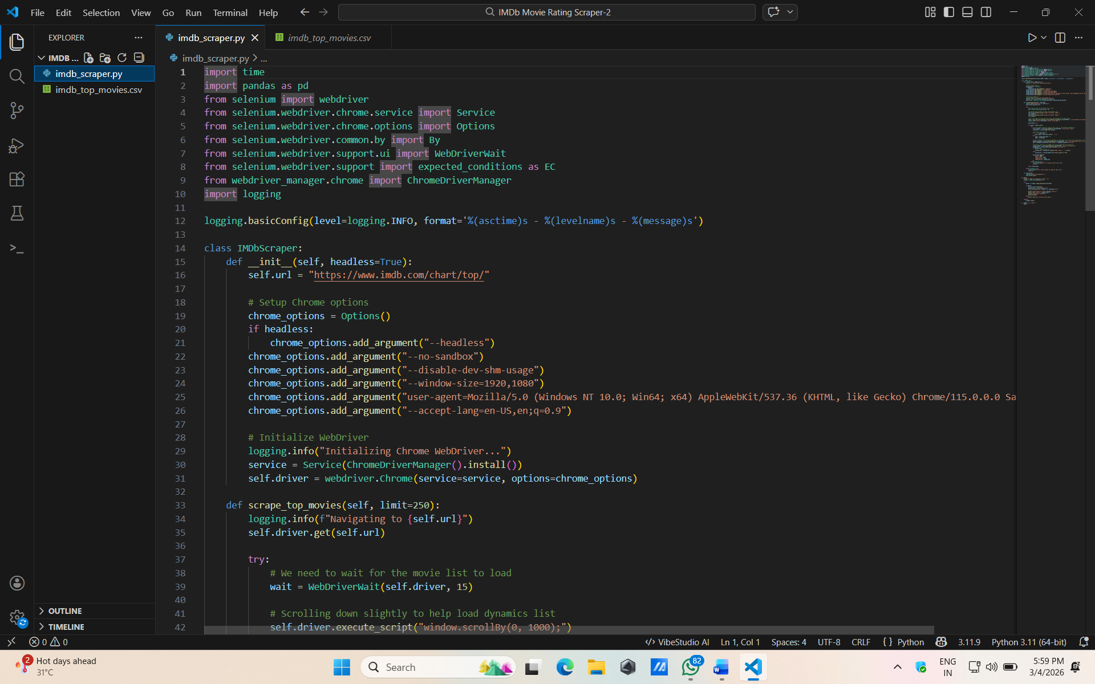
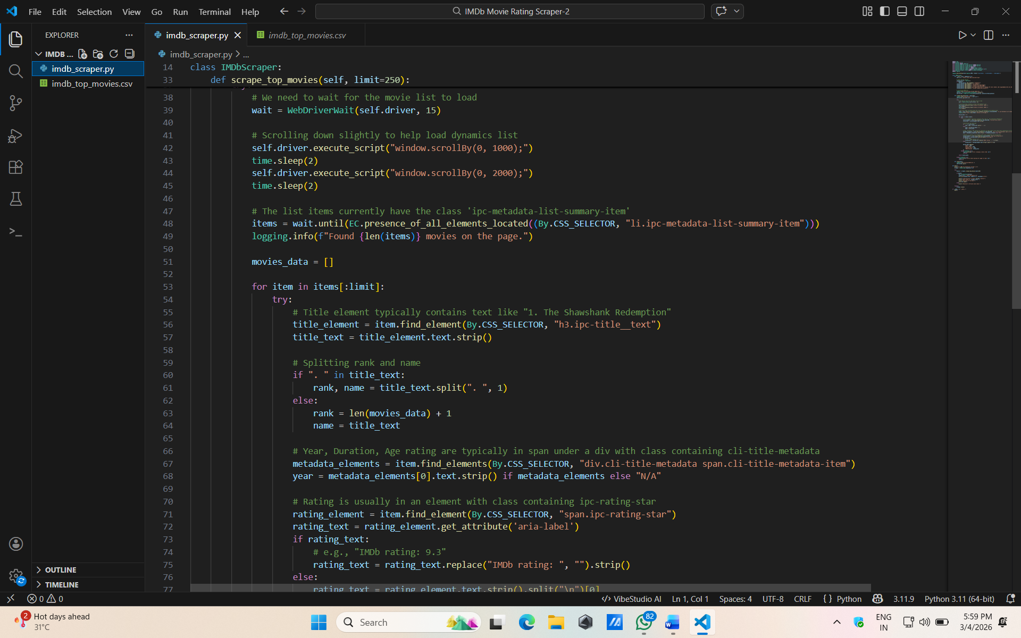

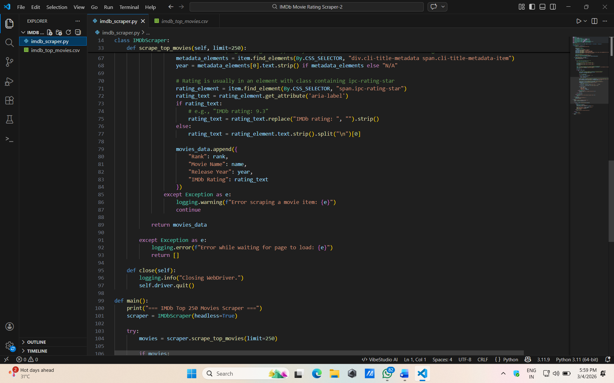
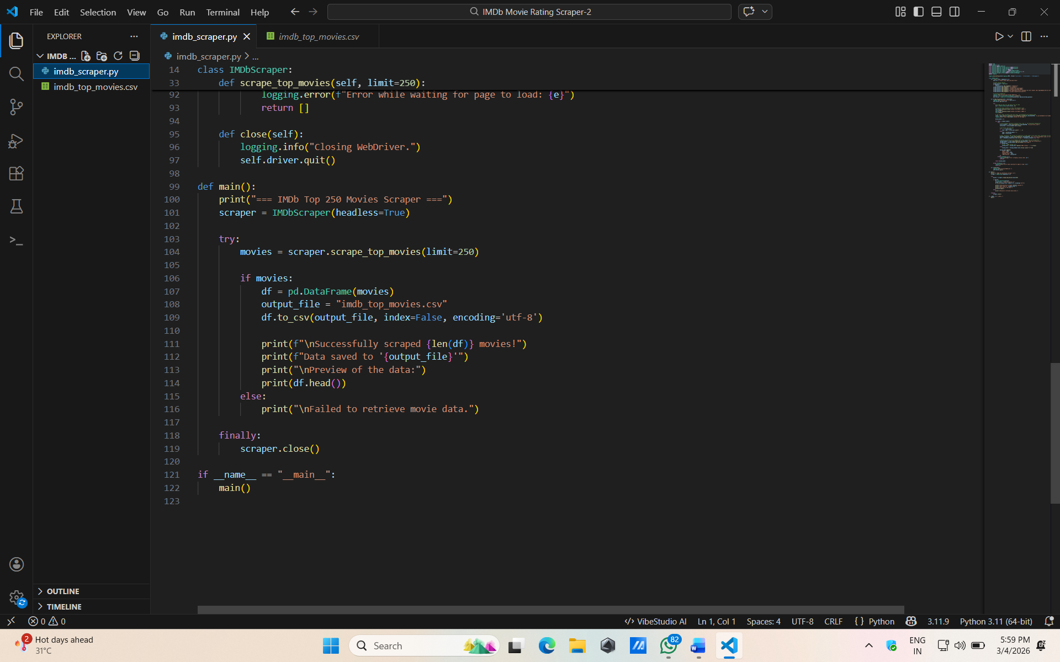

Result:
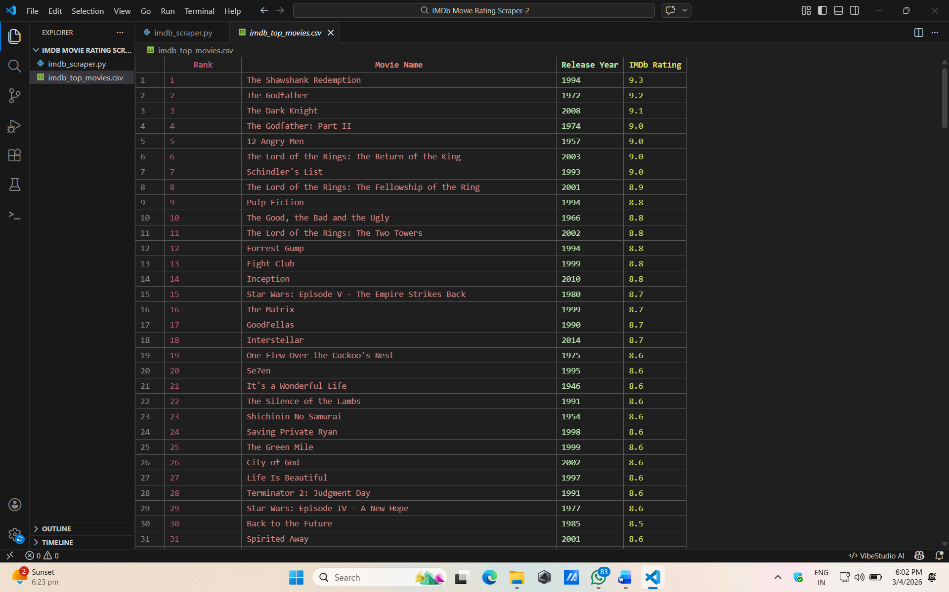
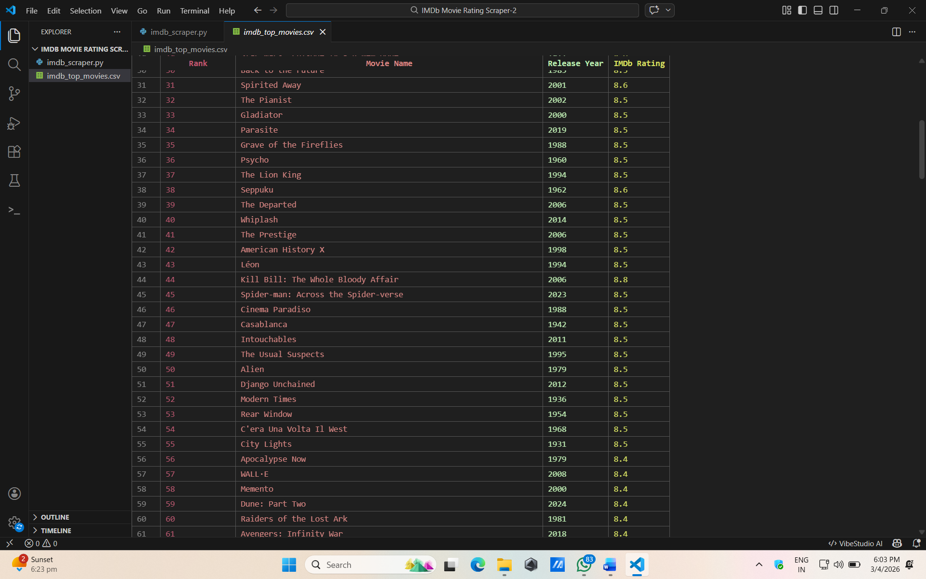

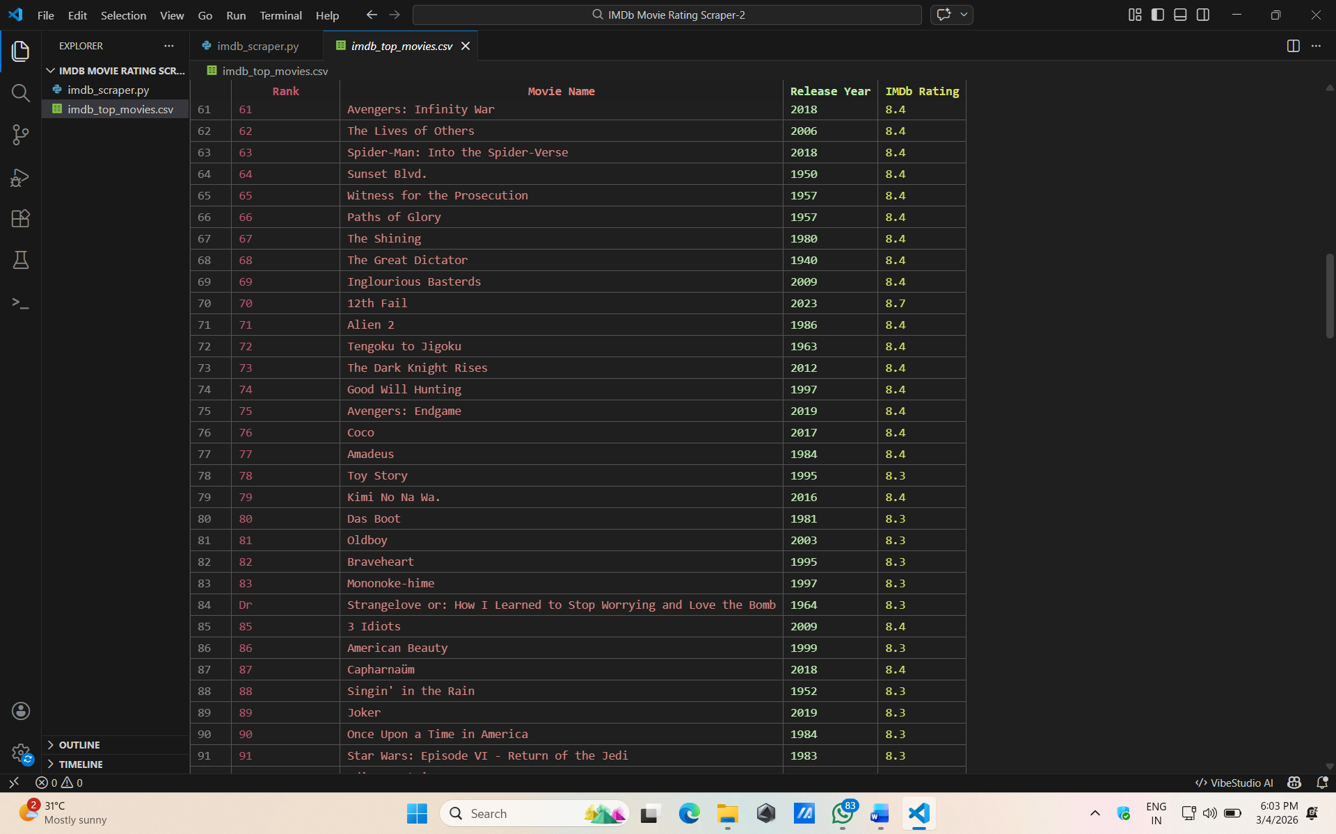
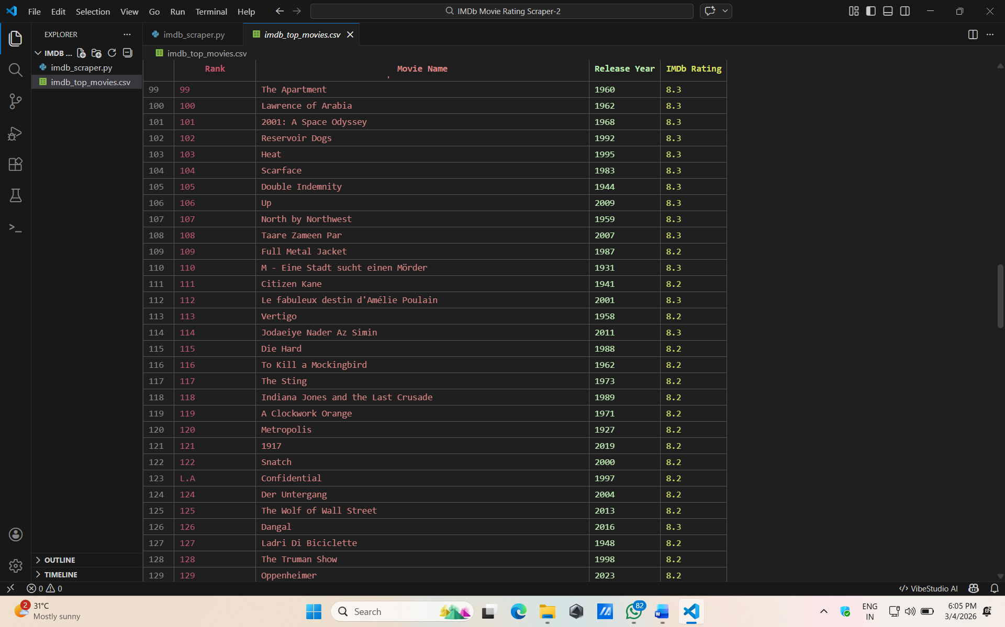

OUTCOMES:
Immediate Benefits:
- Reliable Data Extraction: Successfully handles JavaScript-rendered content that standard scrapers might miss.
- Up-to-Date Ratings: Can be scheduled for daily runs to track real-time rating trends.
- Custom Data Use: Exported files are ready for use in data science dashboards or machine learning models.

Conclusion:
The IMDb Movie Rating Scraper project effectively showcases the use of Selenium for web automation and data processing. By transforming unstructured web data into a clean CSV format, the tool provides a solid foundation for movie trend analysis and recommendation systems. Future iterations can expand the scope to include full cast biographies and user reviews to build a more comprehensive cinematic database.

